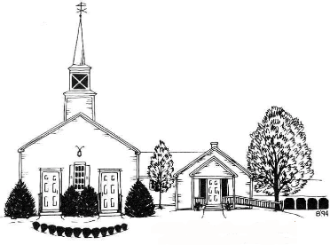
MELVIN VILLAGE COMMUNITY CHURCH
FLEA MARKET, FAIR, AND AUCTION
Saturday, July 9, 2022
9:00AM – 2:00PM (set up begins at 7:30 AM)
476 Governor Wentworth Highway (Rt 109)
Melvin Village, NH 03850
Crafter & Flea Marketer Registration Form
$25 Donation for an apprx. 10’ x 12’ outdoor space (6’ table provided upon request)
To reserve a space, please complete the information below and return this form, along with a check payable to MVCC to: MVCC, P.O. Box 233, Melvin Village, NH 03850

NAME:___________________________________________________________________

CONTACT EMAIL:__________________________________________________________

CONTACT PHONE:__________________________________________________________

VENDOR CATEGORY:
___Flea Market ___Crafts ___(please specify type)________________________________ TABLE REQUESTED: ____YES ___NO
NOTES:
- Vendors will be contacted upon receipt of this form.
- Vendors must carry in/carry out.
- Event is outdoors in the church parking lot rain or shine.
- Please contact Debi Lynch at lynchkg124@gmail.com or 484-467-3242 with any questions.
- All proceeds go directly to the Operation and Missions of MVCC
- For more information on the MVCC Fair & Auction, please visit https://www.mvccnh.org/fairauction

